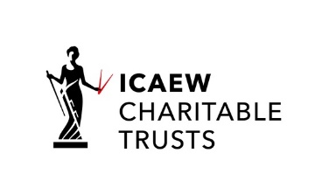 

38th **MANAGEMENT ACCOUNTING RESEARCH GROUP conference**

**in association with the**

**MANAGEMENT CONTROL ASSOCIATION**

**14 – 15th November 2024**

**1st CALL FOR PAPERS**

**Informing the Management Accounting Curriculum**

This year our area of focus will be on how management accounting research, theory and practice affect the curriculum. We’ll be discussing the relevance of our research to teaching practice and how the world of practice and the profession impact the design of exempting accounting degrees, in terms of content and assessment. We especially wish to encourage participants to present teaching cases they are willing to share as well as research on the practice and teaching of Management Accounting, e.g. the effect of digitalisation.

The topics may include:

* How and why has the curriculum evolved in the teaching of management accounting (MA)?
* Integrating emerging themes, e.g. artificial Intelligence (AI), into the MA curriculum
* What are the theories that students taking MA/control modules should engage with?
* Are the levers of control (LOC) still relevant or should the theory/model be updated?
* How are performance measurement systems updated to embrace emerging issues, such as AI?
* The importance of organisational culture in changing management accounting practice
* How/does the current/future job market for management accountants affect what we teach?
* What are the key skills employers across the sectors look for in management accountants?

Plenary speakers:

Professor Roland Speklé, Nyenrode University, Netherlands

Professor Emeritus Trevor Hopper, Sussex University

Professor Joan Ballentine, Ulster University

Professor Wim van de Stede, LSE (Editor in chief of Management Accounting Research)

Recruitment consultant, Reed Group, Birmingham office

Local employer (from Jaguar Land Rover) of management accountants

Research in various stages of development may be presented. PhD-students and early career researchers are particularly encouraged to present their work. Management accounting scholars are also encouraged to participate in workshop sessions, panel discussions and presentations.

|  |
| --- |
| **Extended Abstract /Full paper submission 2nd September 2024**  Please submit to <https://www.conftool.com/marg2024> which will open June 1st  **Review notification W/C 16th September. Presenter registration 4th October. Final ppt files 6th November** |

Sway Information page**:** <https://sway.office.com/lbYaqcvc6v4zxXp0?ref=Link>

Conference secretariat contact details:Maria Podsiadly**,** marg2024@aston.ac.uk